PYTHON OPERATORS

Code:

Arithmetic:

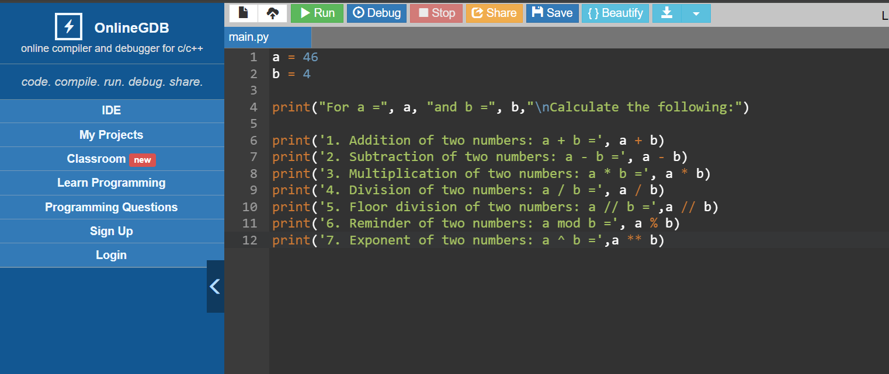

Output:

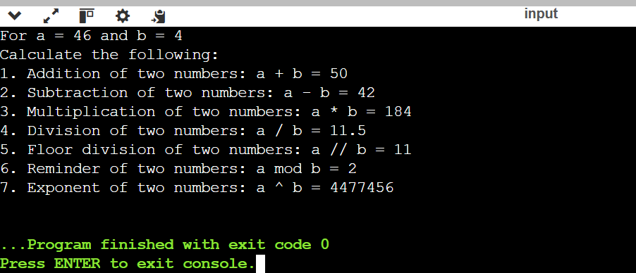

Code:

2.Comparison Operators:

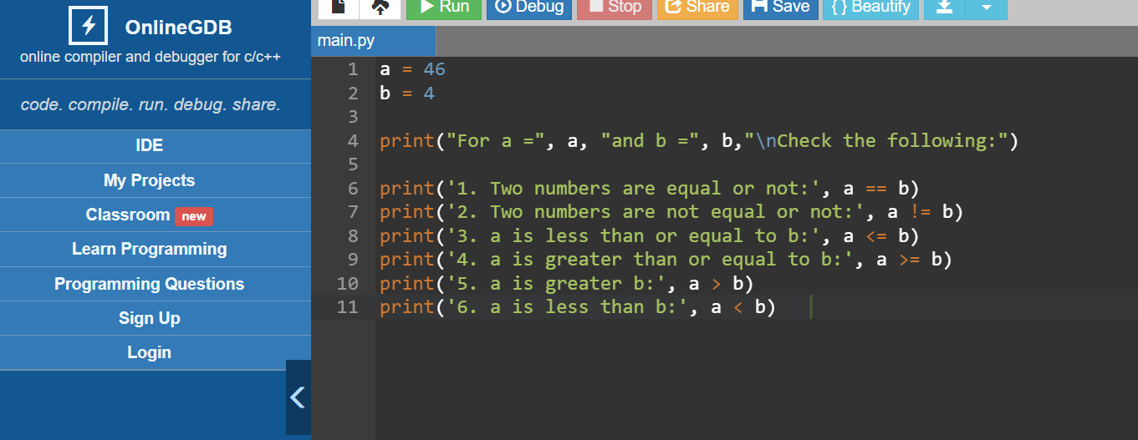

Output:

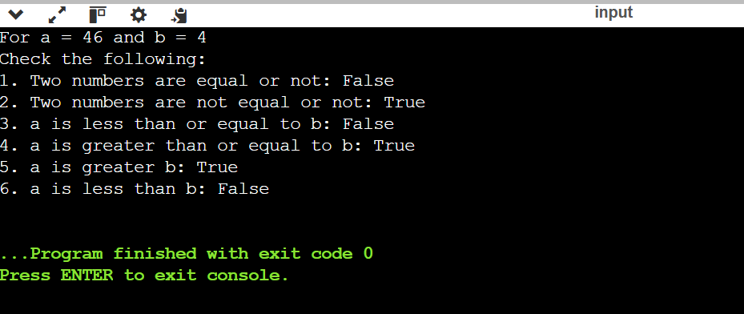

Code:

3.Assignment Operators:

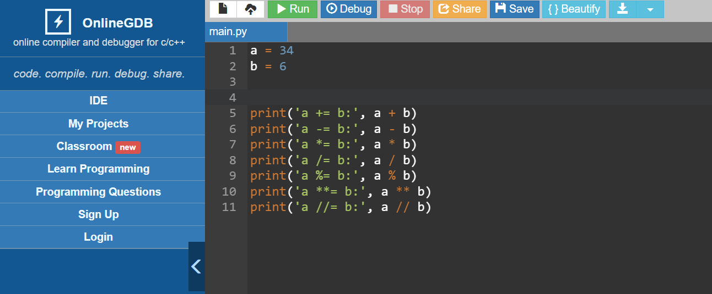

Output:

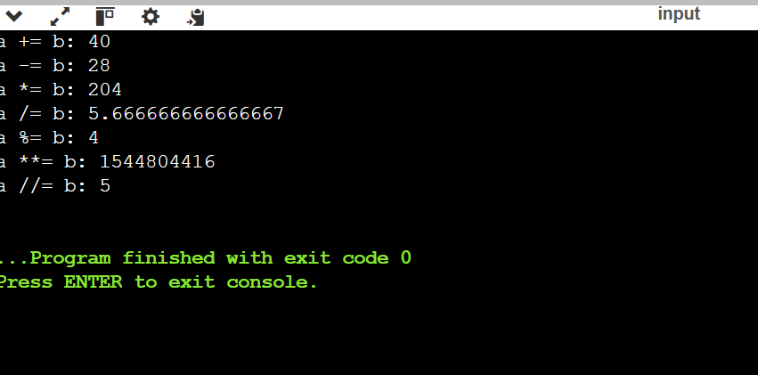

Code:

4.Bitwise Operators:

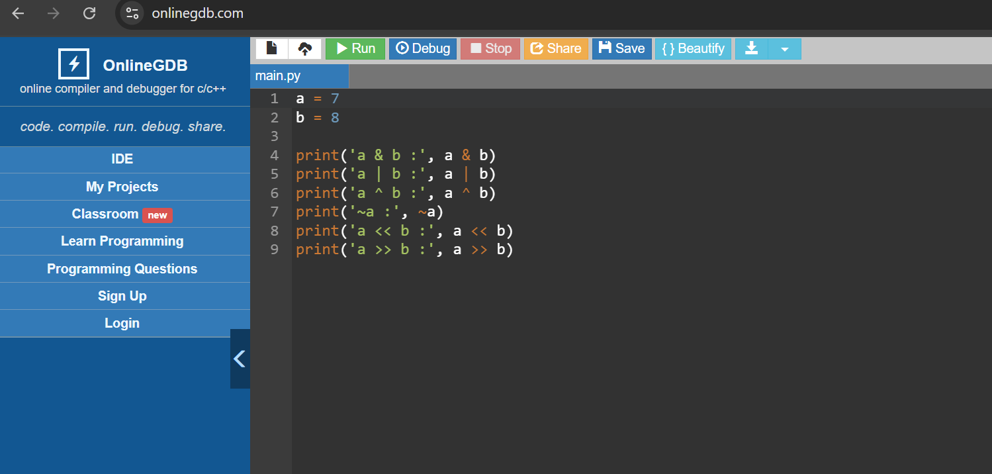

Output:

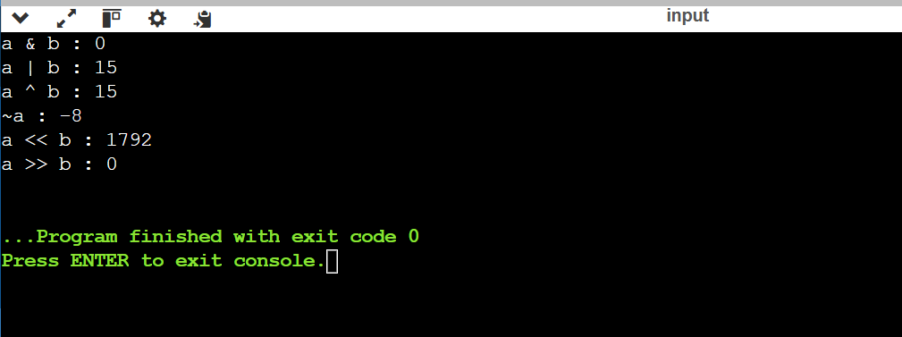

Code:

5.Logical Operators:

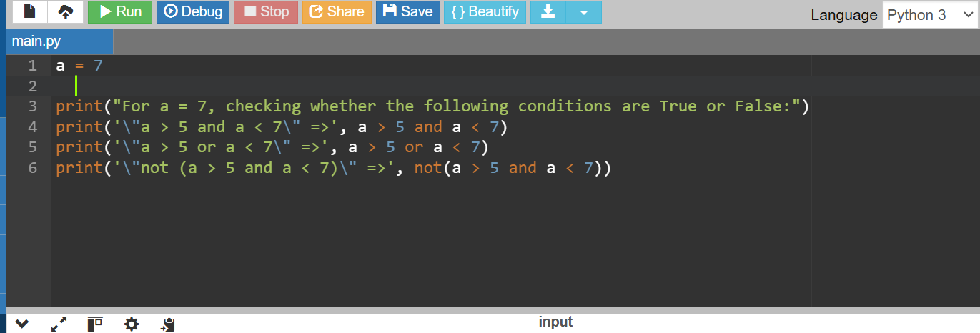

Output:

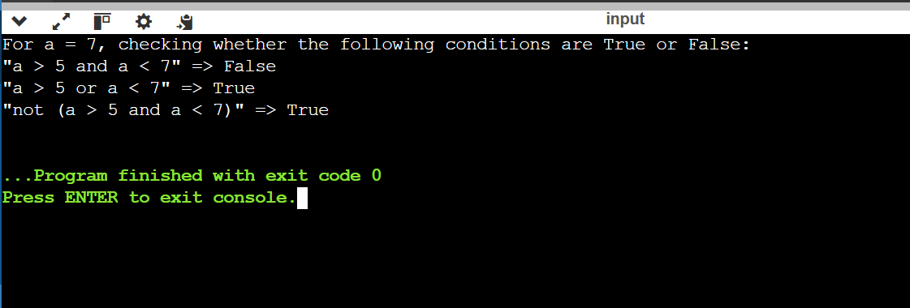

Code:

6.Membership operators:

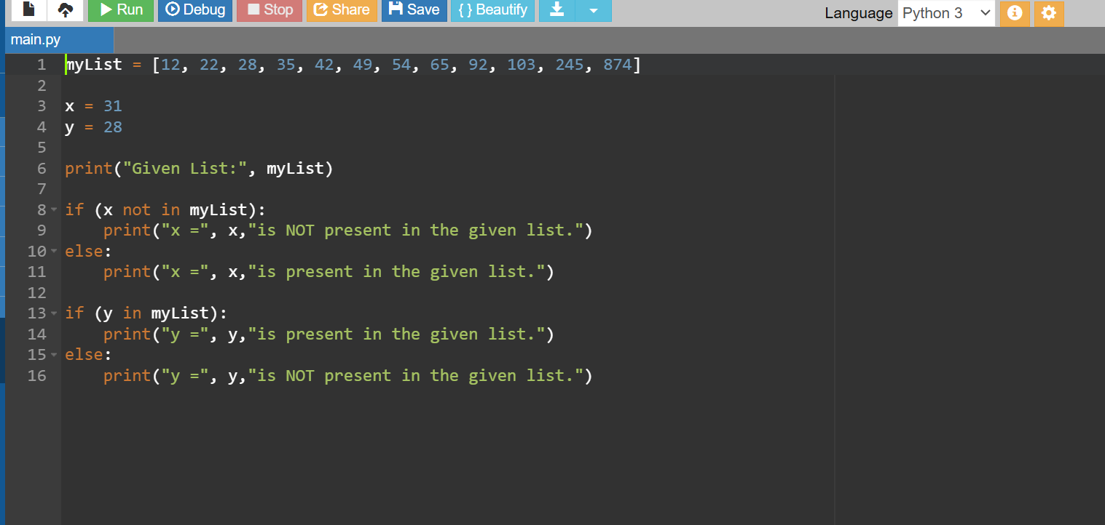

OUTPUT:

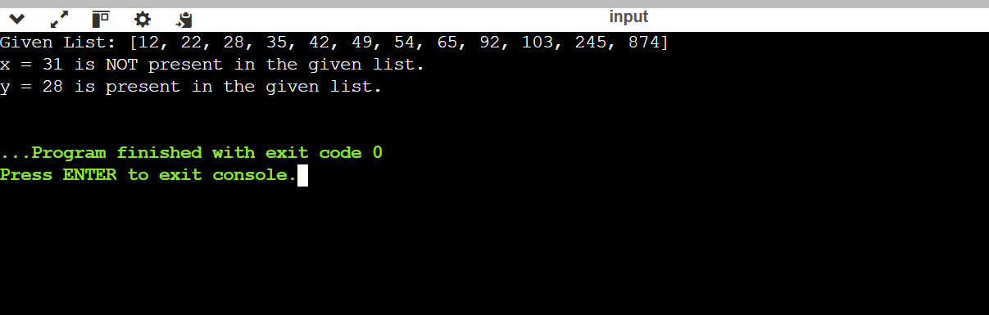

Code:

7.Identity Operators:

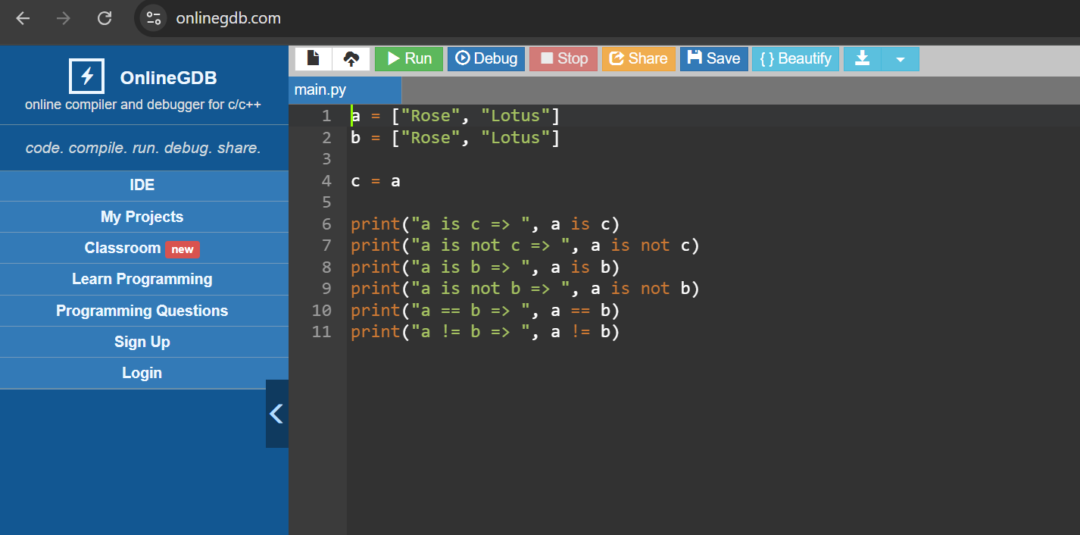

Output:

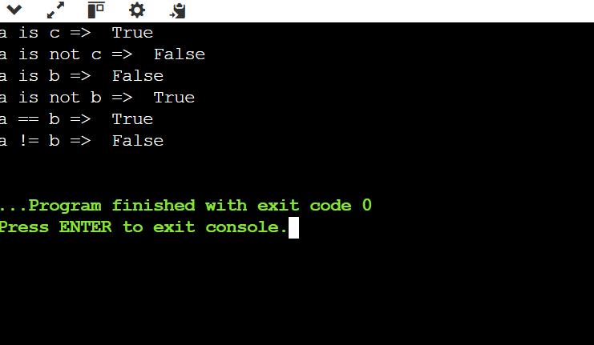

READ CSV FILE IN PYTHON:  
1. CODE:

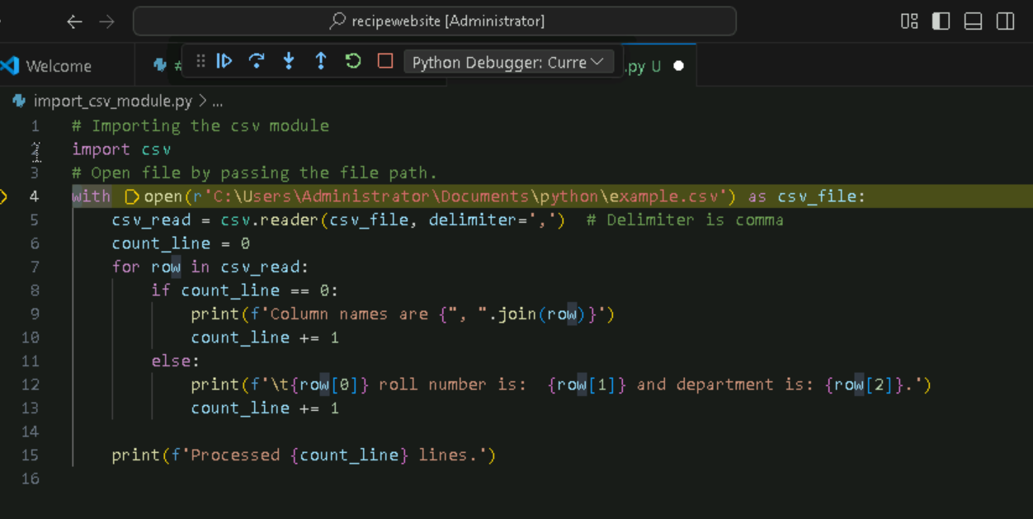

OUTPUT:

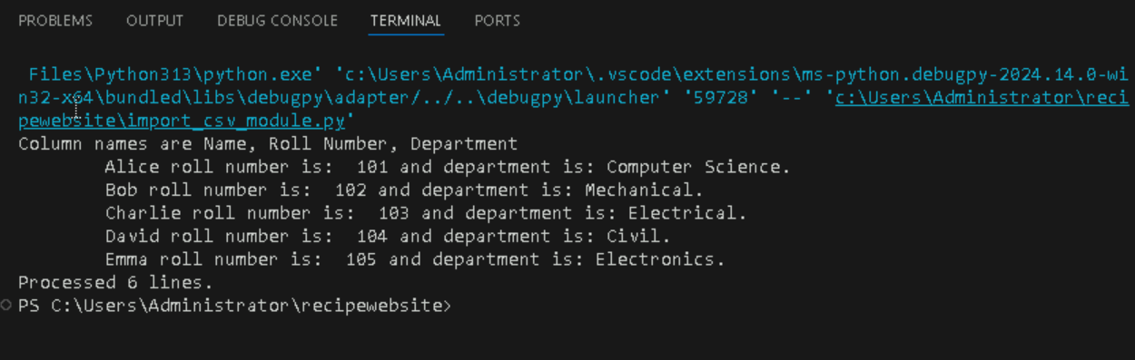

REVERSE A STRING:

1.USING FOR LOOP:

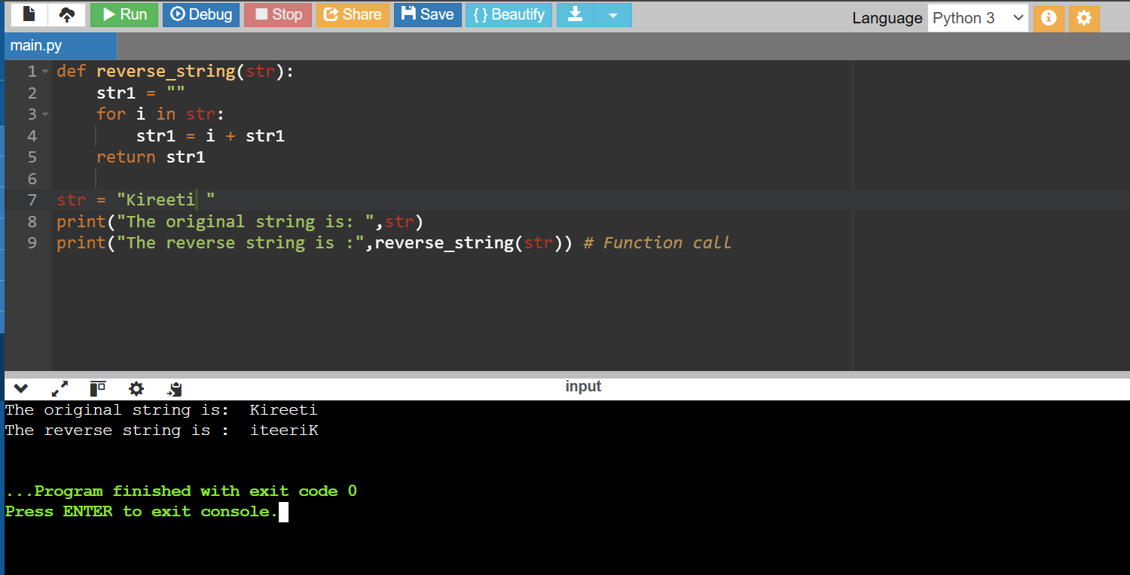

2.USING WHILE LOOP:

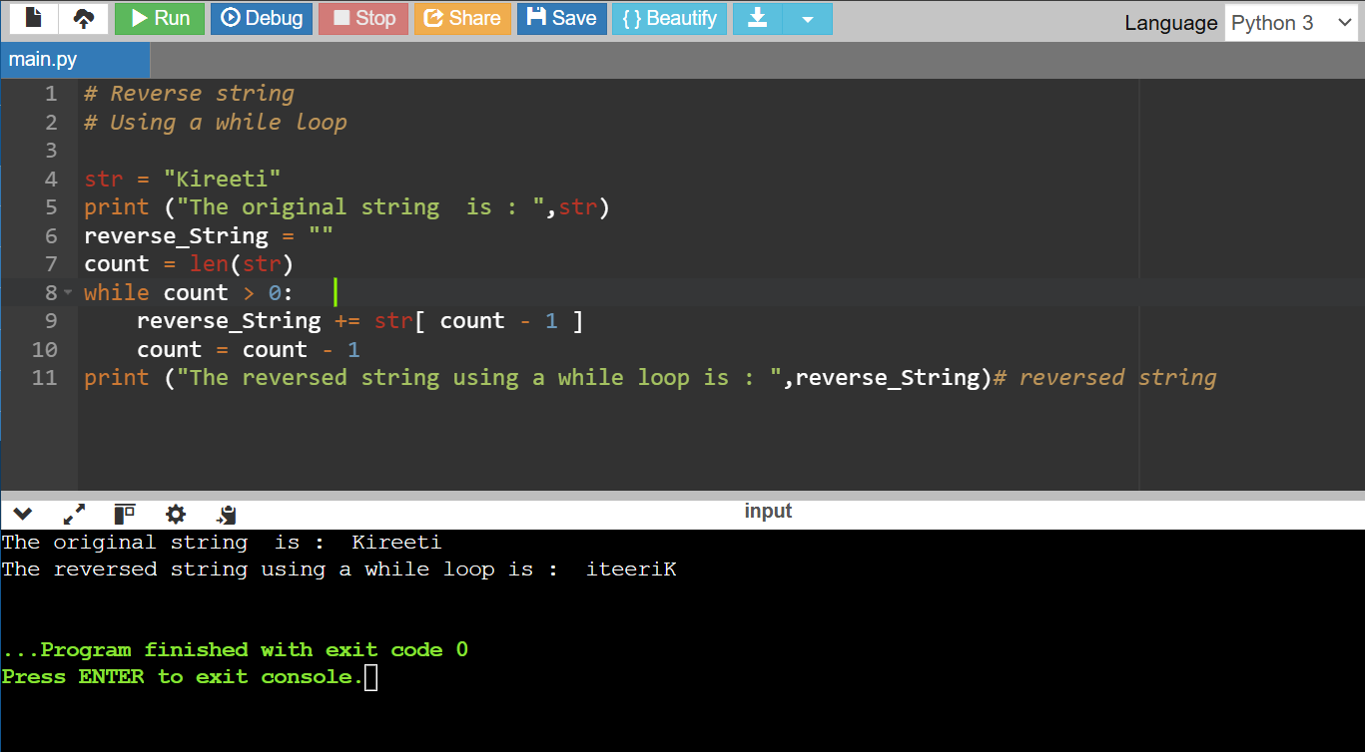

3.USING SLICE OPERATOR:

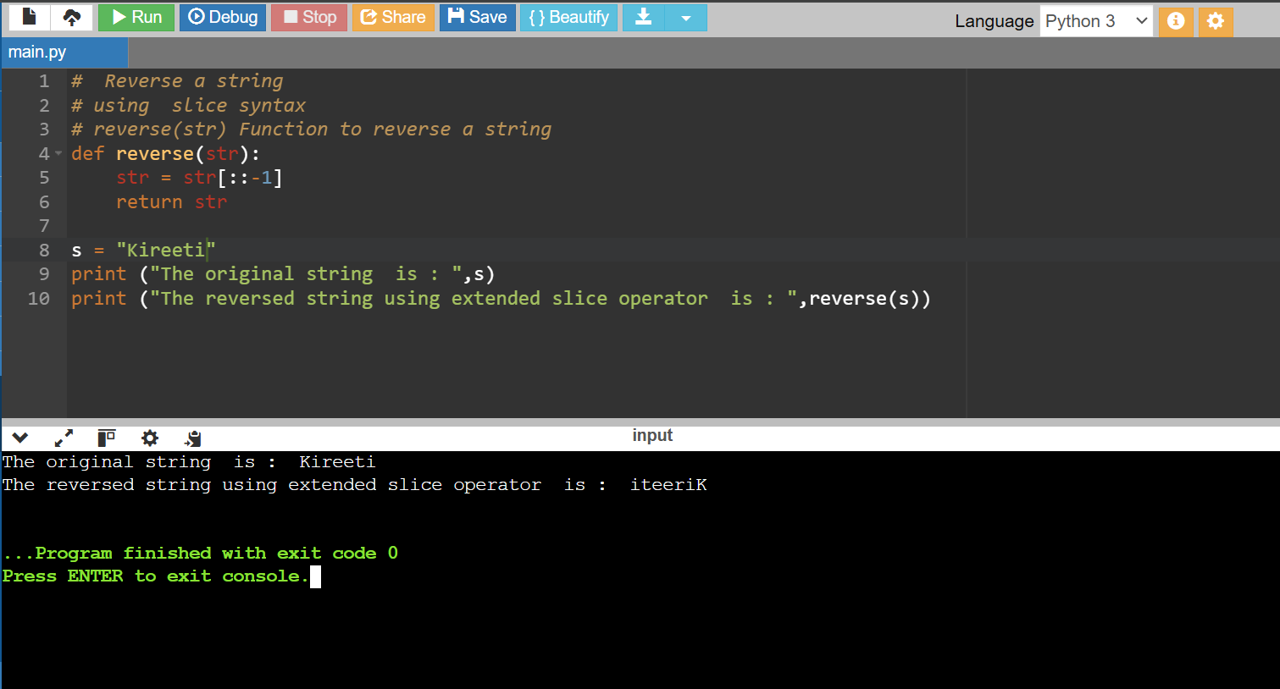

4.USING REVERSED FUNCTION INSIDE JOIN:

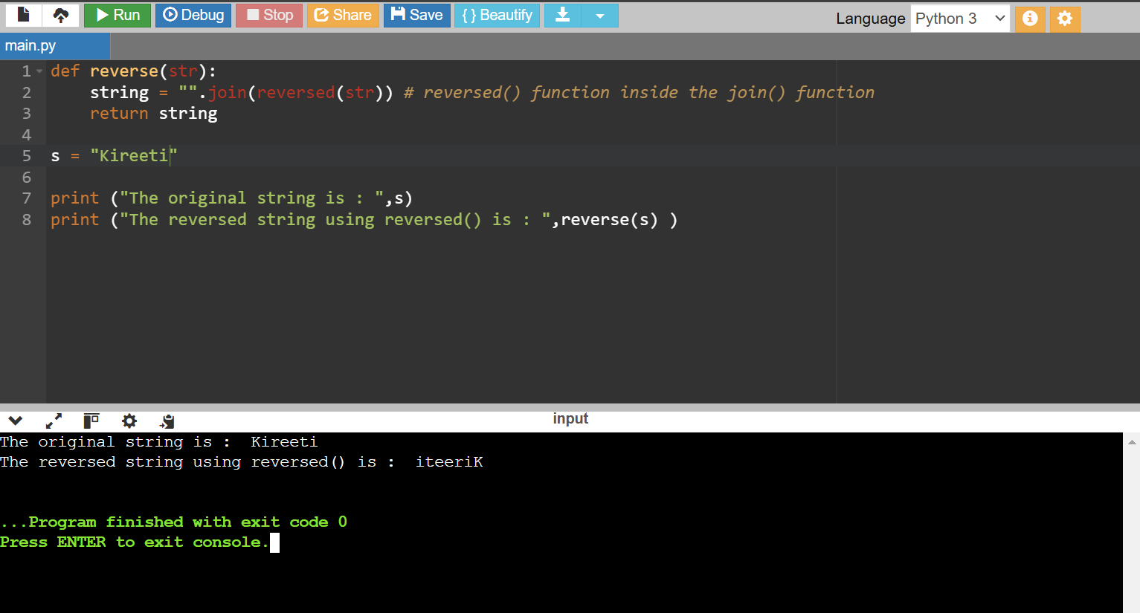

5.USING RECURSION:

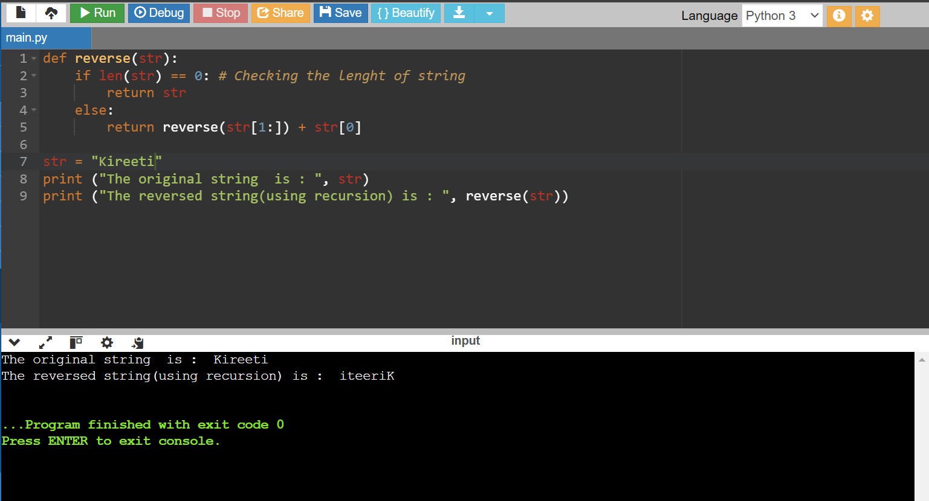

PYTHON IF-ELSE

1.If-Statement:

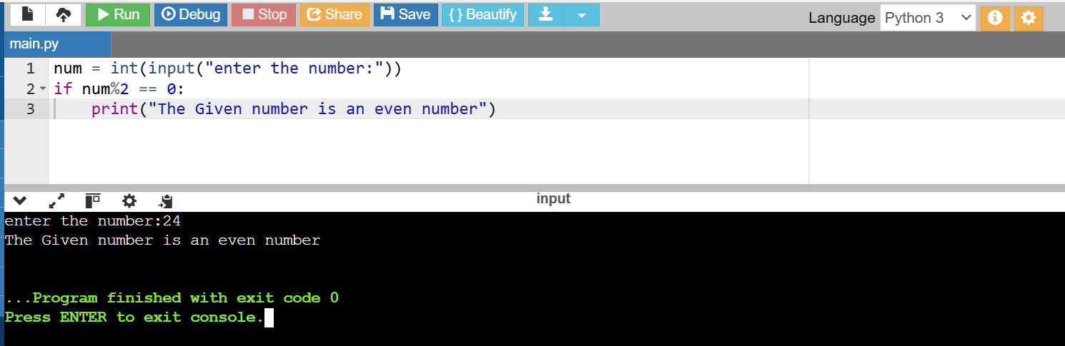

2. print the largest of the three numbers

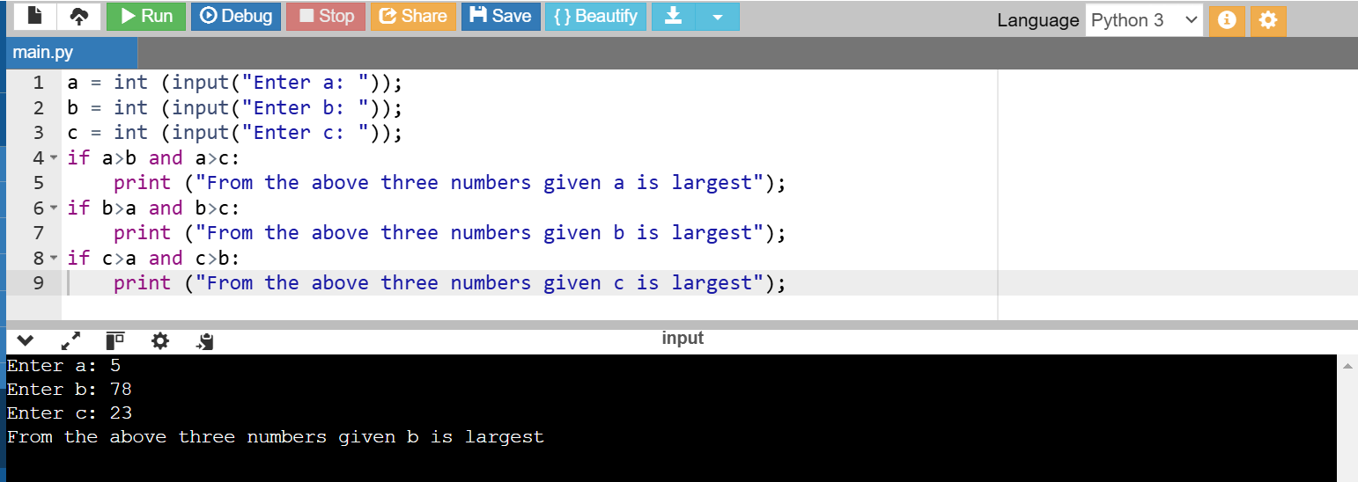

IF-ELSE STATEMENT

1.

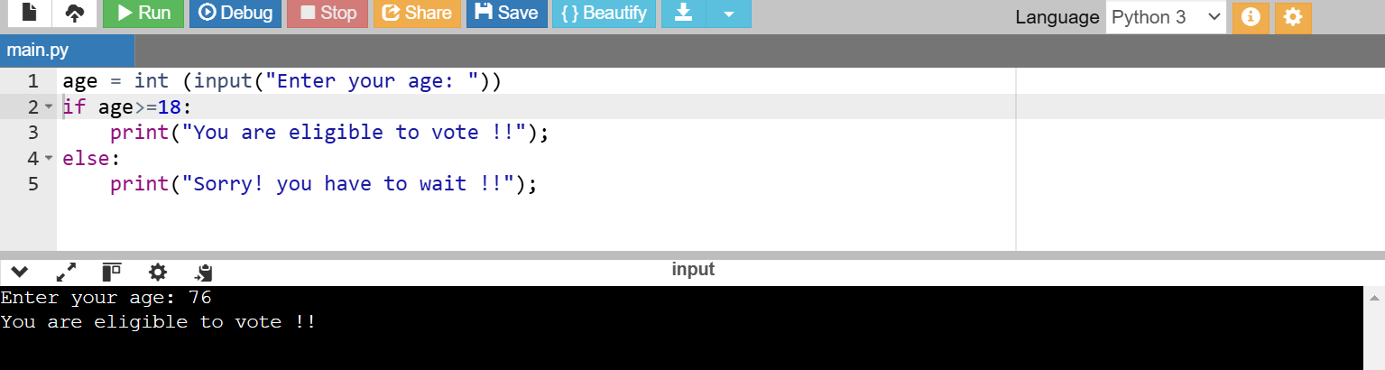

2. check whether a number is even or not:

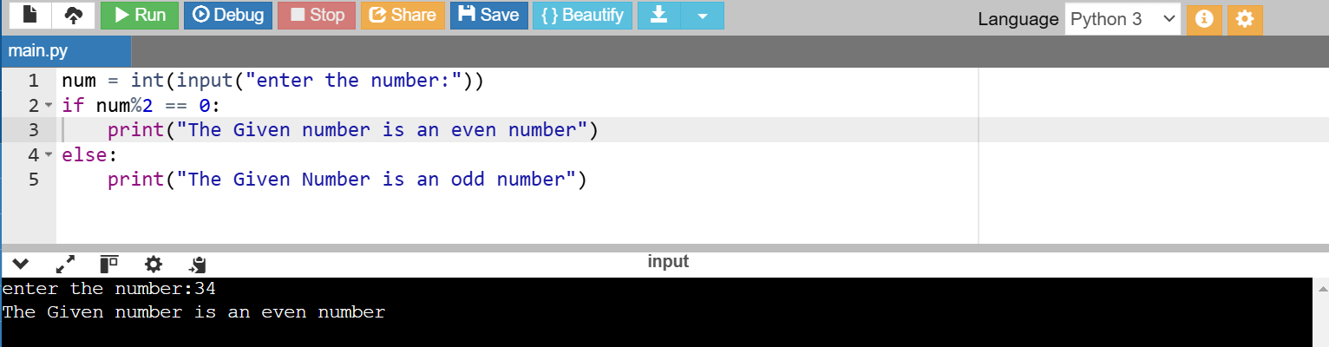

Elif statement:

1.

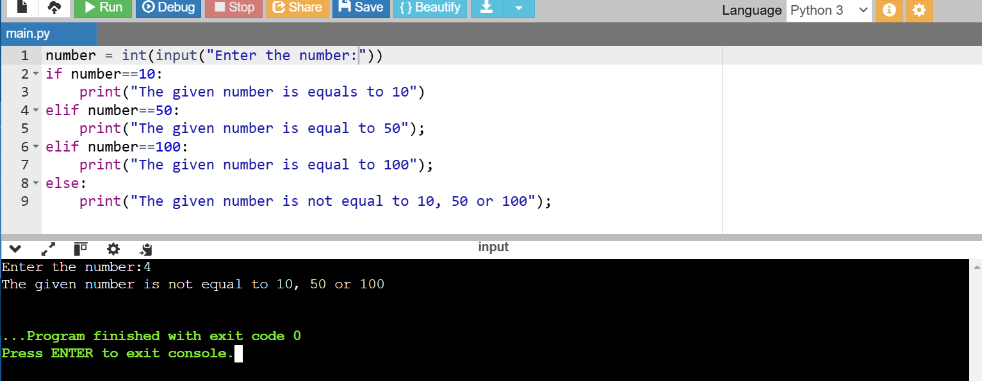

2.

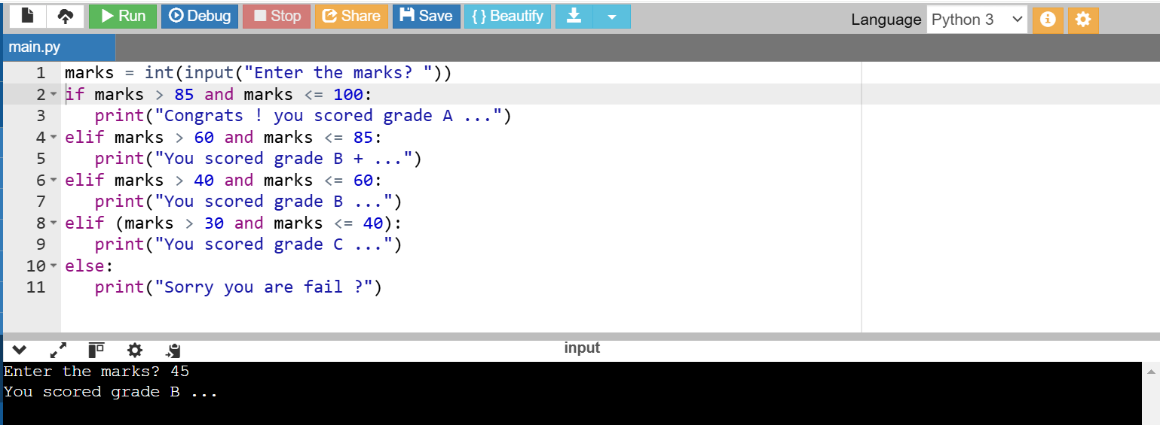

WHILE LOOPS:

1.Sum of Squares:

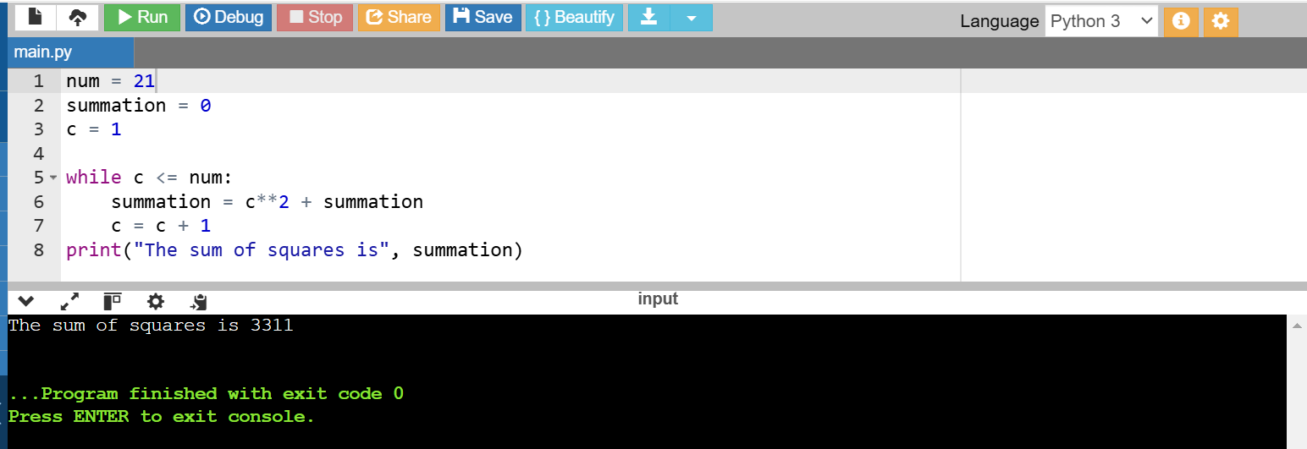

2.Prime Numbers:

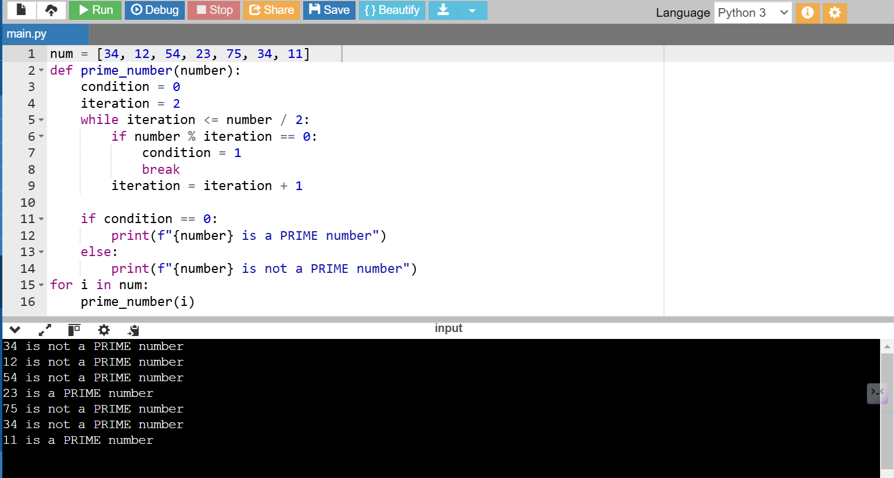

3.Armstrong:

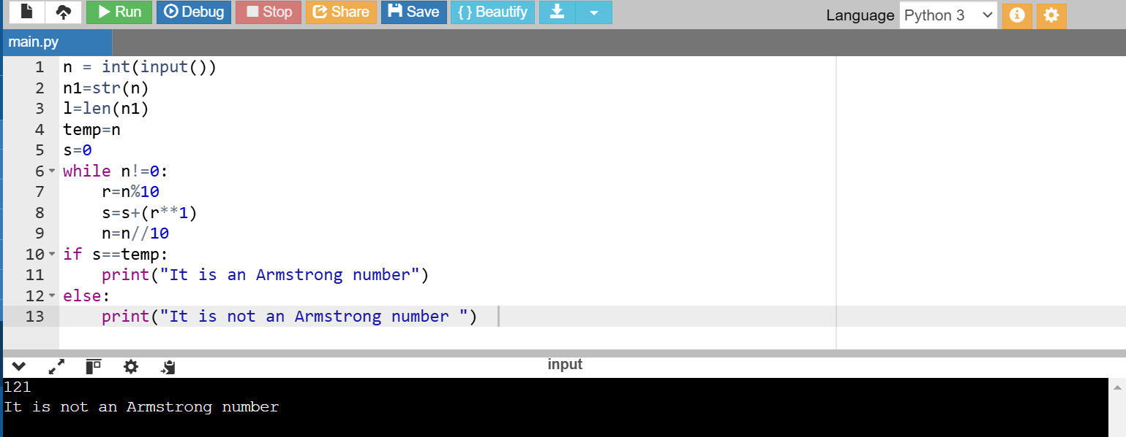

4. Multiplication Table using While Loop:

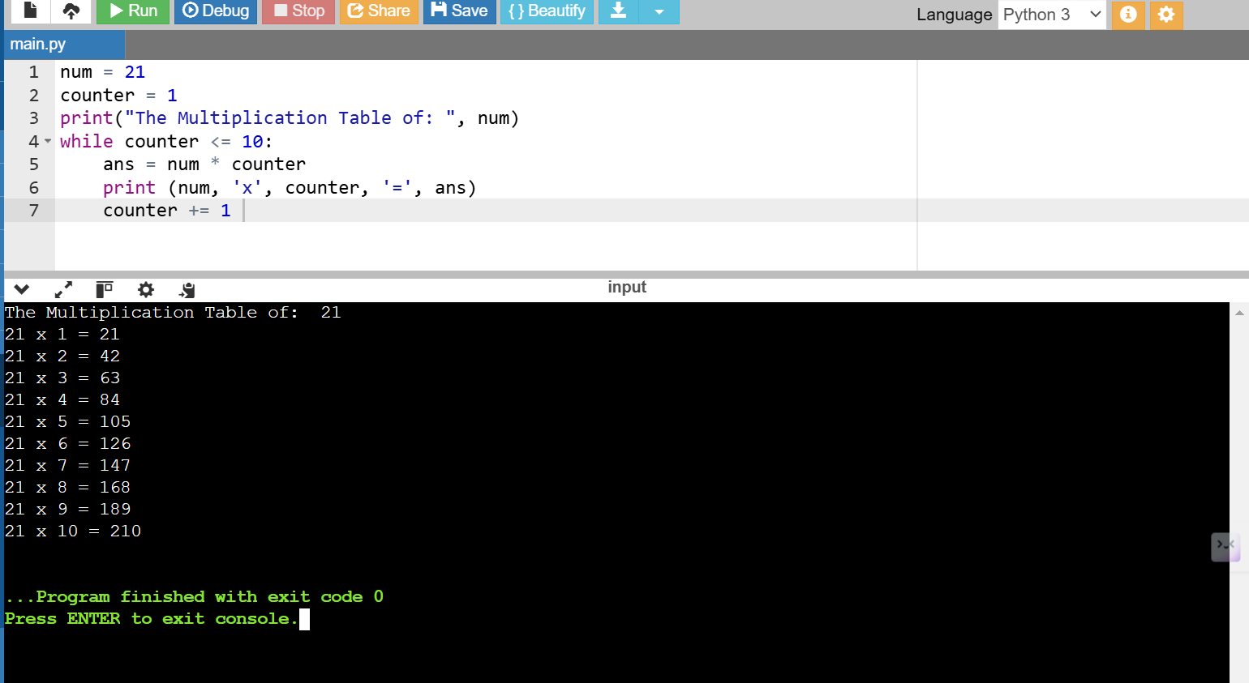

5. Break Statement & Continue Statement:

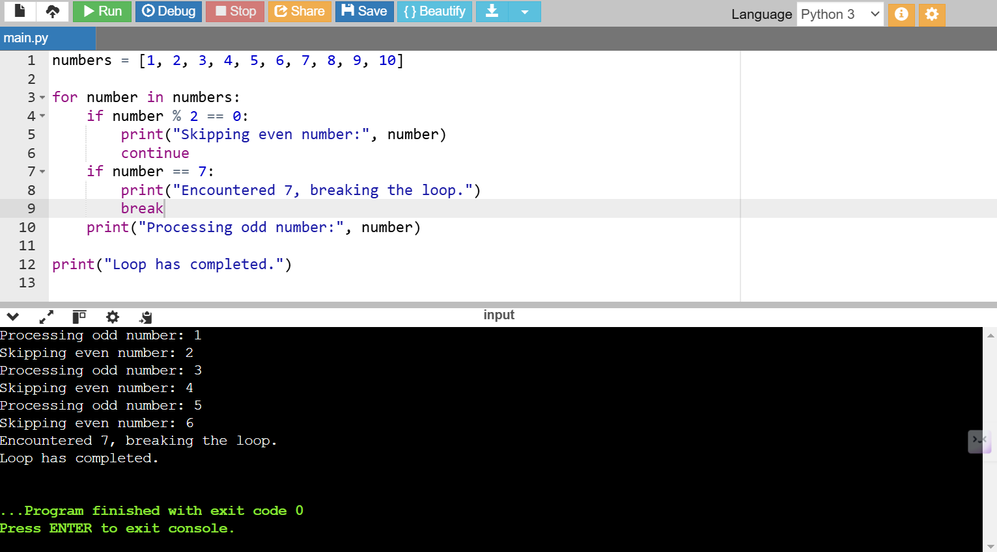

FOR LOOPS:

1.

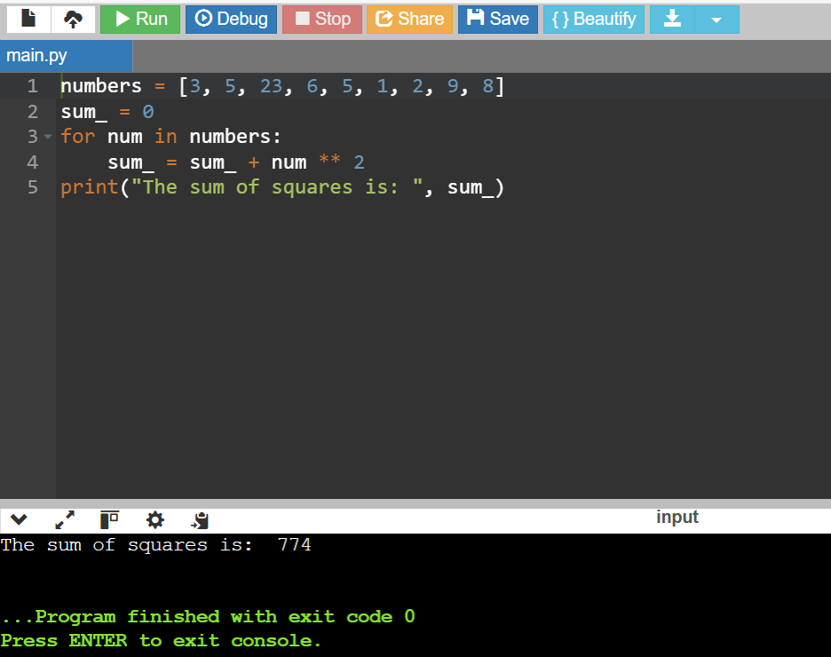

2.

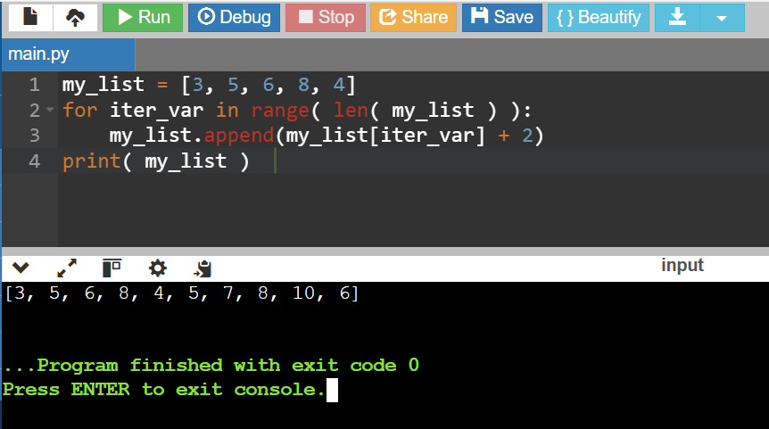

3.

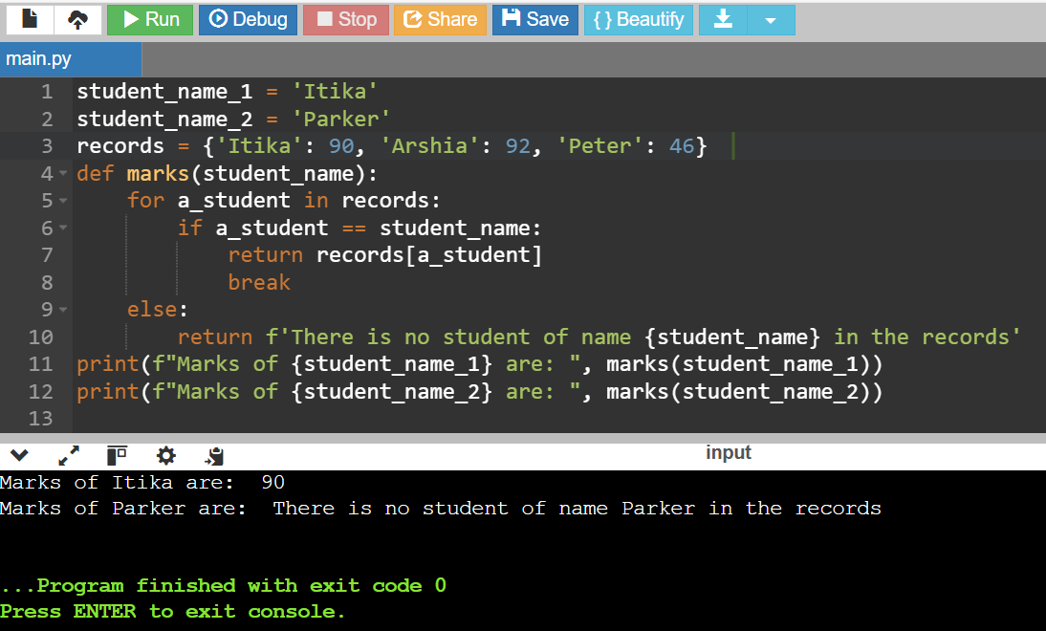

4.

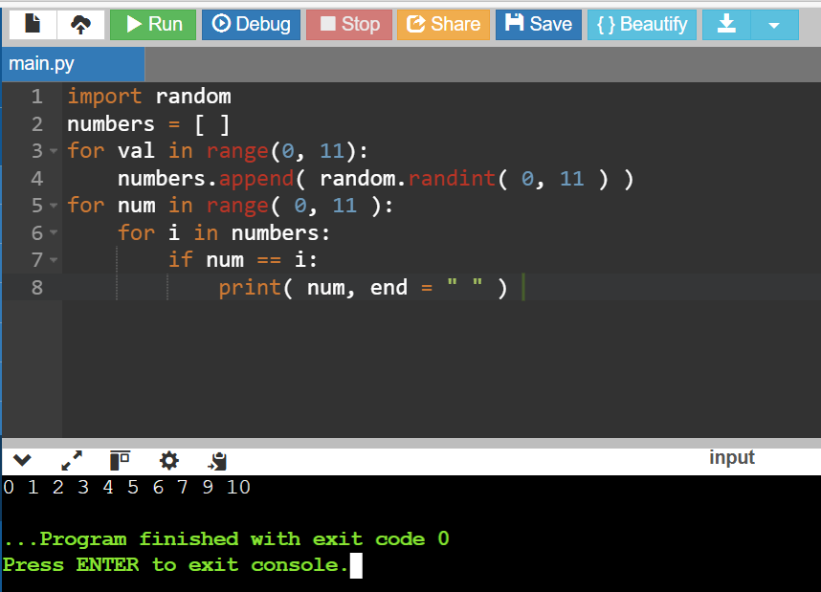

STRINGS:

1.

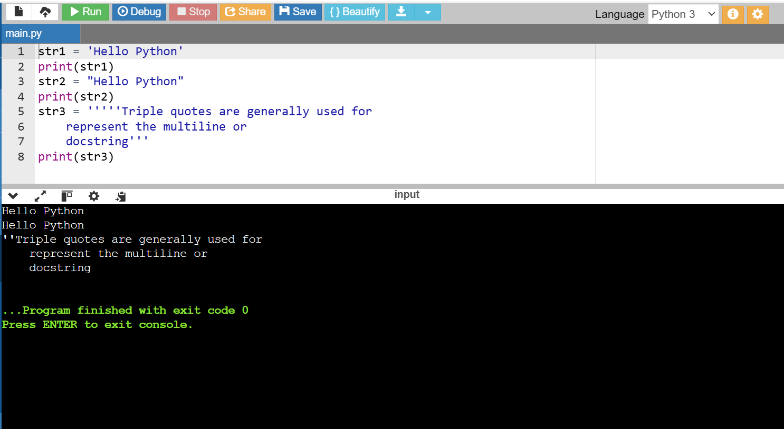

2.INDEXING AND SPLITING:

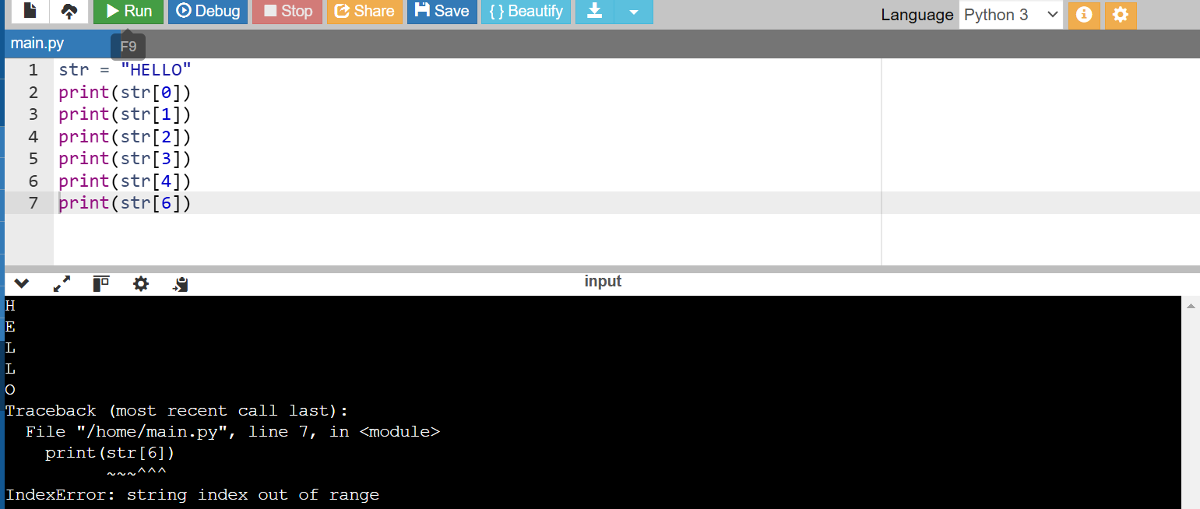

3.

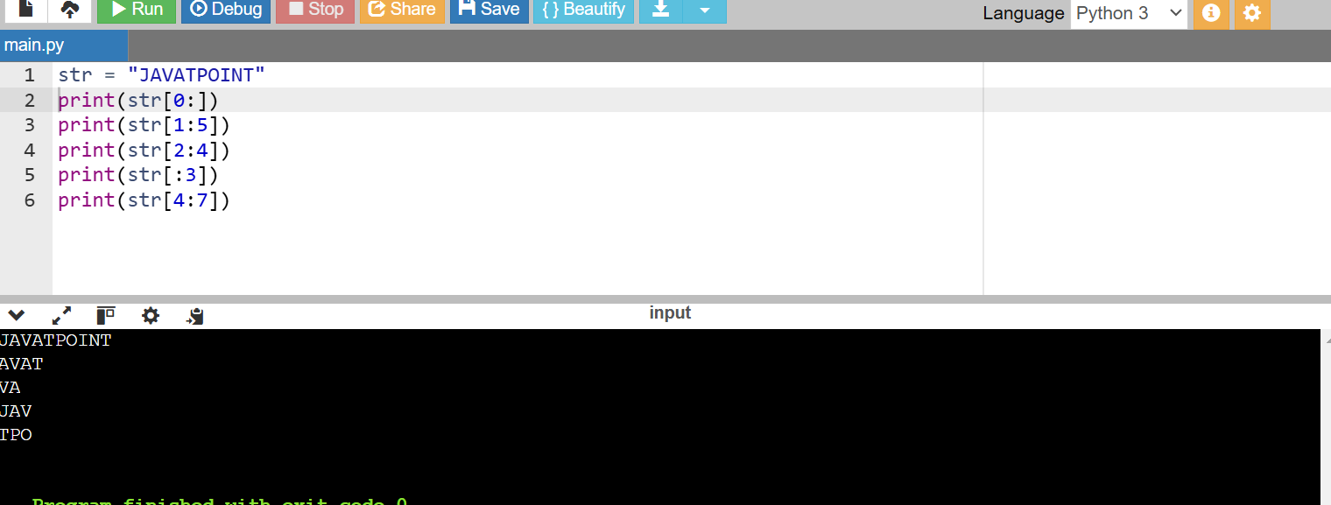4.

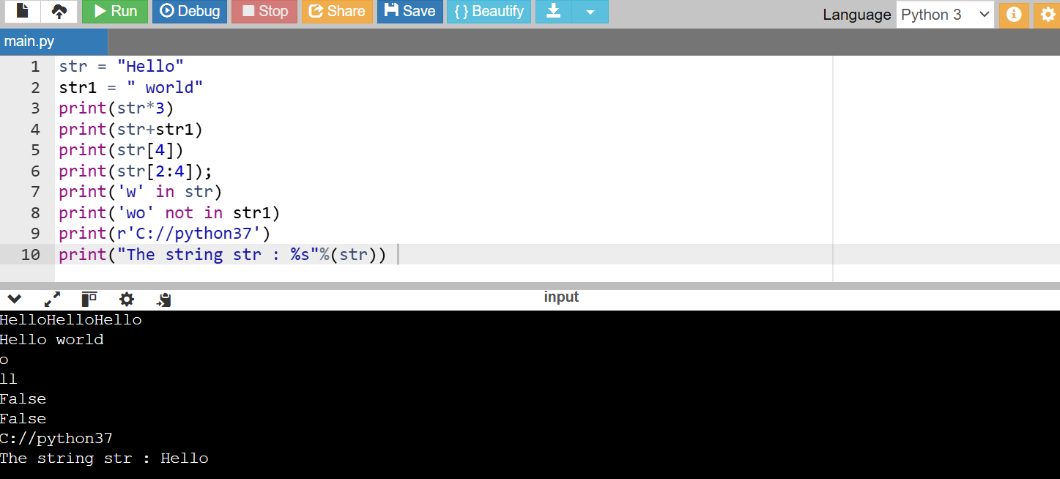

PYTHON LIST VS TUPLE

1. List and Tuple Syntax Differences:

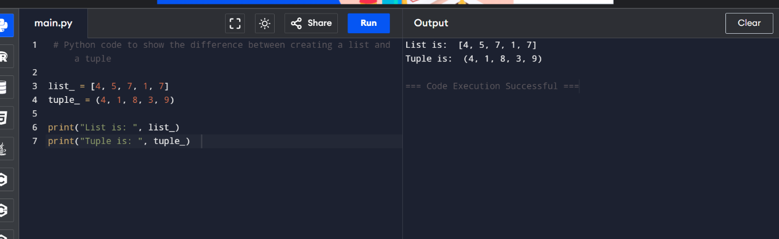

2.

Updating the element of list and tuple at a particular index :

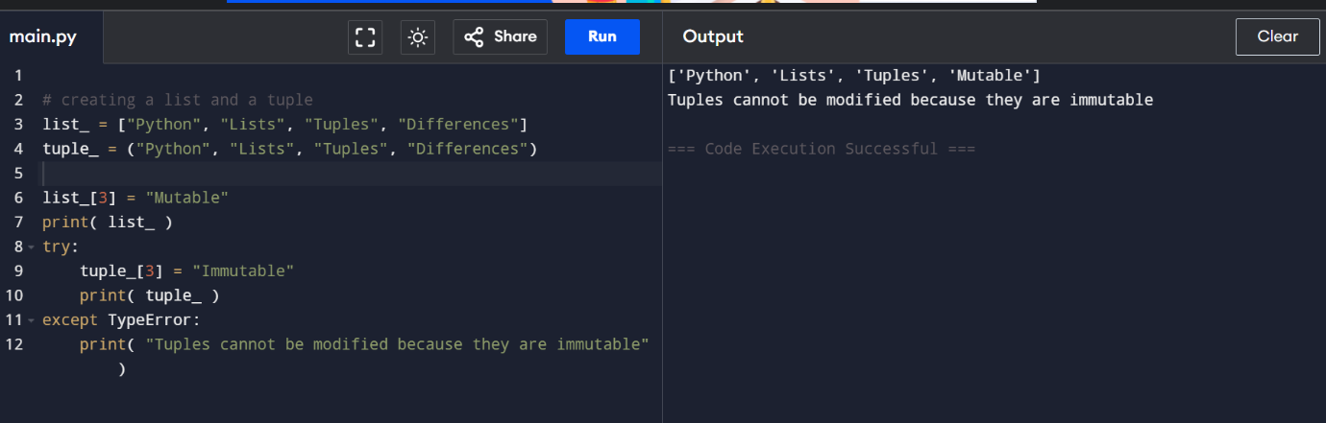

3. Code to show the difference in the size of a list and a tuple:

